**JDK installation for the OPUS development environment   
Windows 7 Professional**

This guide shows the steps to install the Oracle JDK 1.7 on Windows 7 Professional.

The latest available versions of the JDK 1.7 is recommended and used in this guide.

Date: 12. November 2014

# Install JDK 1.7

Note: It's important to have the JDK (Java Development Kit) installed. The JRE (Java Runtime Environment) is not sufficient.

Installation file: jdk-7u71-windows-i586.exe

Follow the wizard. The default path settings are fine.

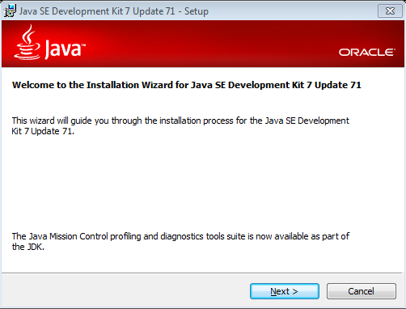

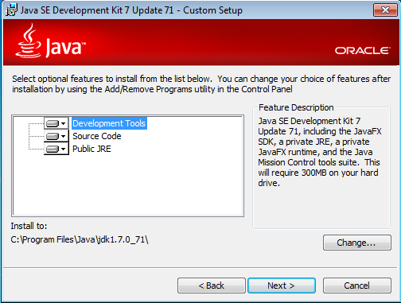

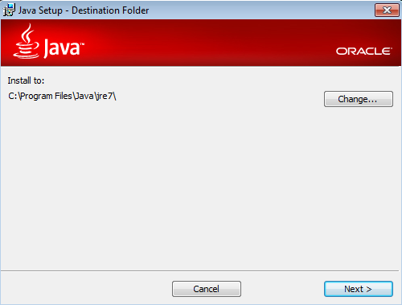

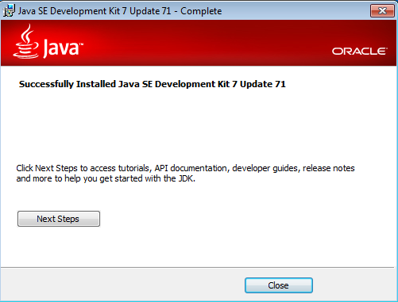

# Configure JAVA_HOME

Go to the Control Panel → System and Security → System

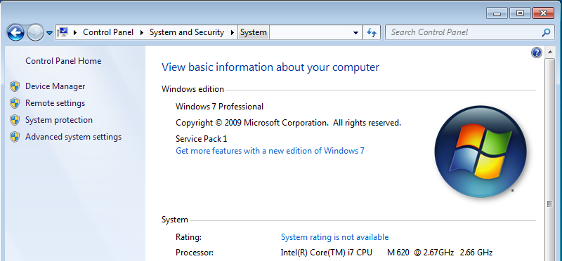

Then select Advancd system settings:

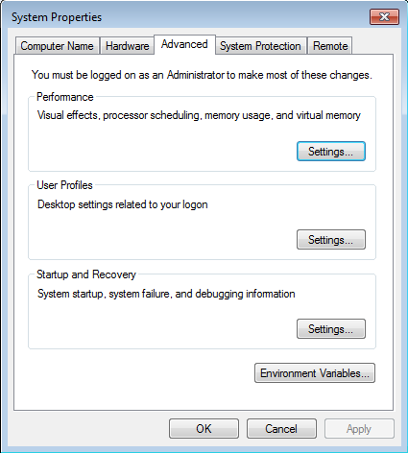

Click on Environment Variables:

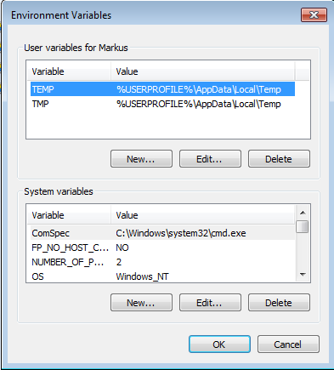

Under System variables, click New... to create a new system variable called JAVA_HOME and enter the path to the installation folder of the JDK:

Then click OK.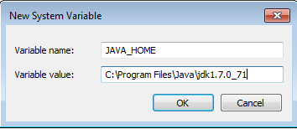

Next select the Path variable in the list of system variables:

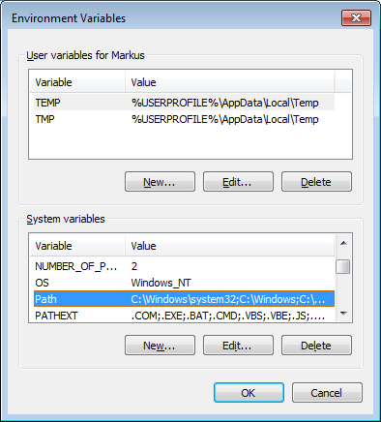

Click Edit... and add ;%JAVA_HOME%\bin to the Path:

Click OK in all System settings dialogs to close them.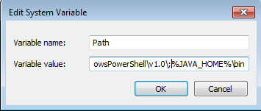

Note: The installation of the JDK is now finished. The installation can be verified by opening a command prompt and executing java -version and javac -version. Both have to respond with the installed JDK version:

